LPS: DFT-Supported Reference Bands
A peak-by-peak reanalysis of powder Raman vs. fragment DFT — replacing a single R² with defensible, matched evidence
Prepared for: Sukesh P (M24IM1007)
Reanalysis date: 30 August 2026 — follow-up to the LPS Evidence Audit (29 Aug 2026)
What this document does
The evidence audit found that the previously published fit quality (R² = 0.180) could not be independently reproduced from the current pipeline, and flagged two specific bugs. Rather than re-quote that number, this document reprocesses the same existing data — no new measurements — with the bugs fixed, and replaces the single whole-curve R² with a peak-by-peak comparison: each experimental band is matched one-to-one against a DFT-predicted band (with a fragment assignment), a position error (Δ), and a confidence tier. The result is a defensible list of DFT-supported LPS reference bands, and a three-layer comparison against the literature.
Data used (no new experiments)
Experimental: sec-60_power-20_i-30.xlsx — the "final optimized" LPS powder Raman spectrum per LPS documentation.docx (E. coli O111:B4 LPS, Sigma-Aldrich L2630; B&W Tek BWS465-785H, 784.92 nm; 60 s integration, 20% laser power, 30 accumulations).
DFT: the five raw Gaussian fragment exports in lps sim/ (KDO, D-glucosamine, Heptose, Myristic Acid, Phosphoric Acid) — discrete "Peak information (Harmonic)" lists, scaled by 0.9613.
What was fixed from the audit
Preprocessing order corrected: the experimental spectrum is now windowed to 200–2000 cm⁻¹ FIRST, then ALS-baseline-corrected, Savitzky-Golay smoothed, and min-max normalized LAST — this is the order LPS documentation.docx itself describes, and it avoids the previous bug where normalizing over the full native range (which extends past 2800 cm⁻¹) before windowing collapsed the 200–2000 window into a narrow intensity slice.

Whole-Curve Fit — Shown for Transparency, Not as the Main Evidence
Per the audit’s own conclusion, a single global R² is a weak way to claim a match. It is reported here only so nothing is hidden — the real evidence is the peak-by-peak table in the next section.
Fit | RMSE | R² | r | Note
Previously published (run_final.py output) | 0.1850 | 0.1799 | 0.5078 | Could not be reproduced from the current script (see audit) — shown for reference only.
Old (buggy) pipeline, reproduced here | 0.2399 | -468.1650 | 0.4523 | Normalizing before windowing — confirms the bug is catastrophic, not cosmetic.
Corrected pipeline — NNLS composite | 0.2178 | 0.0508 | 0.4976 | Bugs fixed, weights refit. This is the honest whole-curve number — see note below.
Corrected pipeline — equal-weight composite | 0.2396 | -0.1483 | 0.4130 | Unweighted average of the 5 fragments, for comparison.
Corrected-pipeline NNLS weights: KDO 43.7%, Glucosamine 28.5%, Heptose 27.0%, Myristic Acid 0.8%, Phosphoric Acid 0.0%.
Reading this table honestly: fixing the two audit-identified bugs changes the whole-curve R² from a catastrophic −468 (old bug) to a modest +0.051 (corrected) — still below the previously published 0.180. That gap means the original 0.180 was produced by some additional, undocumented difference in the pipeline beyond the two bugs found here; it is not reproduced by this reanalysis either, and should continue to be treated as an open discrepancy, not silently matched.

Experimental LPS Powder vs. DFT Fragment Composite
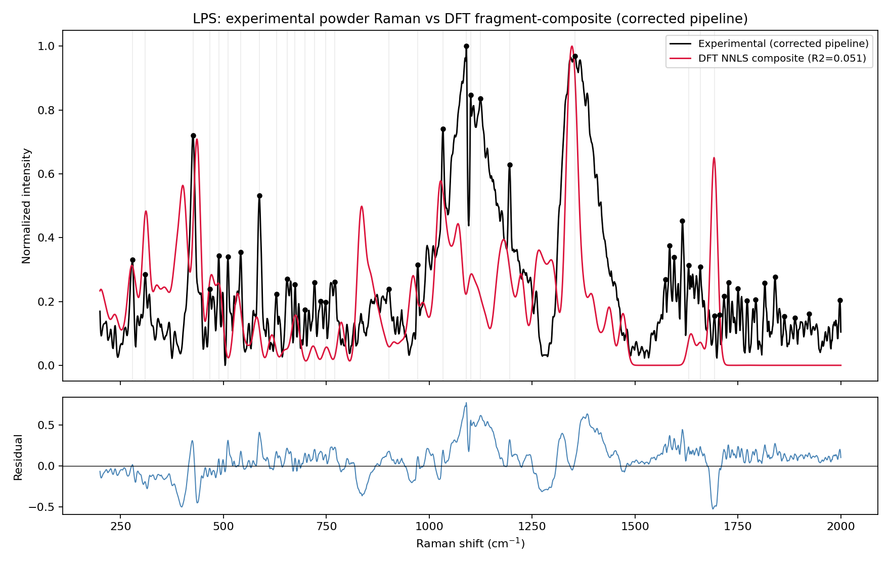
Black dots mark the 43 "major" experimental bands used for peak matching (prominence ≥ 0.08 on the corrected, normalized spectrum). The DFT composite (red) uses corrected-pipeline NNLS weights. Note the DFT composite falls to ~0 above ~1750 cm⁻¹ — the five simulated fragments predict almost no activity there, while the experimental spectrum still shows numerous small bands in that region (see “unmatched peaks” below).

Peak-Matching Method
1. Experimental peaks: scipy.signal.find_peaks on the corrected, normalized spectrum, prominence ≥ 0.08, minimum spacing 10 cm⁻¹ → 43 major bands in 200–2000 cm⁻¹ (a denser, lower-threshold list of 104 peaks at prominence ≥ 0.02 also exists in the underlying data if a finer scan is wanted later).
2. DFT candidate peaks: every scaled discrete-mode peak from each of the 5 fragments with activity ≥ 5% of that fragment’s own maximum, within 200–2000 cm⁻¹ → 178 candidate modes pooled across all 5 fragments.
3. One-to-one matching: a Hungarian (linear-sum-assignment) match between the 43 experimental peaks and the 178 DFT candidates, restricted to pairs within ±15 cm⁻¹ — this prevents one strong DFT mode from "claiming" multiple nearby experimental peaks or vice versa.
4. Confidence tiers: High = |Δ| ≤ 5 cm⁻¹ AND only one fragment has a candidate mode within ±15 cm⁻¹ of that position (unambiguous assignment). Moderate = |Δ| ≤ 10 cm⁻¹ (or ambiguous — more than one fragment nearby — within 5 cm⁻¹). Low = |Δ| ≤ 15 cm⁻¹. Matches beyond 15 cm⁻¹ are not reported.
Result: 26 of 43 major experimental peaks (60%) have a defensible DFT match — 4 High, 20 Moderate, 2 Low confidence. Across the 26 matched pairs: MAE = 3.94 cm⁻¹, RMSE = 5.57 cm⁻¹.

DFT-Supported LPS Reference Bands (26 defensible matches)
Important distinction: call these "DFT-supported LPS reference bands," not "validated LPS-specific biomarkers." A DFT match here means a computed fragment mode falls within ±15 cm⁻¹ of an observed powder-Raman band — it is not yet a statistically validated, chance-corrected, or LPS-specific assignment (many of these fragments’ functional groups are common to other biomolecules too).
LPS Powder (cm⁻¹) | DFT (cm⁻¹, scaled) | Δ (cm⁻¹) | Fragment / Mode | Other fragments within ±15 cm⁻¹ | Confidence
721.0 | 717.9 | 3.1 | KDO | (unique) | High
748.0 | 750.4 | -2.4 | Heptose | (unique) | High
1659.0 | 1659.1 | -0.1 | KDO | (unique) | High
1693.0 | 1692.1 | 0.9 | KDO | (unique) | High
279.0 | 278.6 | 0.4 | Heptose | Glucosamine, Phosphoric Acid | Moderate
310.0 | 311.2 | -1.2 | Glucosamine | Heptose | Moderate
426.0 | 425.9 | 0.1 | Phosphoric Acid | Glucosamine, Heptose, KDO | Moderate
467.0 | 467.0 | 0.0 | Glucosamine | Heptose, KDO | Moderate
489.0 | 490.3 | -1.3 | Glucosamine | Heptose, KDO, Myristic Acid | Moderate
511.0 | 502.5 | 8.5 | Myristic Acid | (unique) | Moderate
542.0 | 541.5 | 0.5 | Heptose | Glucosamine, KDO | Moderate
587.0 | 581.7 | 5.3 | Heptose | Glucosamine | Moderate
629.0 | 619.7 | 9.3 | Glucosamine | KDO | Moderate
655.0 | 651.5 | 3.5 | Myristic Acid | Heptose, KDO | Moderate
674.0 | 676.3 | -2.3 | Heptose | KDO | Moderate
771.0 | 777.9 | -6.9 | Phosphoric Acid | (unique) | Moderate
972.0 | 962.4 | 9.6 | Heptose | (unique) | Moderate
1033.0 | 1031.0 | 2.0 | Myristic Acid | Glucosamine, Heptose, KDO, Phosphoric Acid | Moderate
1090.0 | 1098.0 | -8.0 | Heptose | Glucosamine | Moderate
1101.0 | 1102.8 | -1.8 | Glucosamine | Heptose, Myristic Acid | Moderate
1124.0 | 1122.3 | 1.7 | KDO | Glucosamine, Myristic Acid | Moderate
1195.0 | 1196.4 | -1.4 | Glucosamine | Heptose, KDO | Moderate
1354.0 | 1354.8 | -0.8 | KDO | Glucosamine, Heptose | Moderate
1630.0 | 1635.6 | -5.6 | Glucosamine | (unique) | Moderate
698.0 | 683.5 | 14.5 | KDO | (unique) | Low
902.0 | 913.2 | -11.2 | Heptose | KDO, Phosphoric Acid | Low
Major experimental peaks with no DFT match within ±15 cm⁻¹ (17 of 43): 736.0, 1574.0, 1584.0, 1595.0, 1615.0, 1705.0, 1716.0, 1727.0, 1750.0, 1772.0, 1793.0, 1815.0, 1840.0, 1863.0, 1888.0, 1923.0, 1998.0 cm⁻¹. These cluster heavily in the 1574–1998 cm⁻¹ region — consistent with the DFT composite’s near-zero predicted activity there (see plot). Whether this reflects a real spectral feature the 5-fragment model cannot explain, or a baseline/edge-of-window artifact near the top of the 200–2000 cm⁻¹ window, is not resolved by this reanalysis.

Three-Layer Comparison: Literature → Our Powder → DFT-Supported
Every literature peak found across the four (partly conflicting) source documents identified in the evidence audit is listed here, not just the ones that happen to line up — so the gaps are visible too, not only the hits. "Kundu-text" entries are flagged: a separate project document found that the paper actually attributed to Kundu et al. contains zero LPS mentions, so this source’s own identity is itself an unresolved internal conflict (preserved, not resolved, here).
Literature (cm⁻¹) | Source | Assignment | Our Powder (cm⁻¹) | DFT-Supported (cm⁻¹, fragment, confidence) | Status
550 | A (Wu 2021, Enteric LPS) | beta(CH2) ring | 542 | 542 (Heptose, Moderate) | Strong (literature -> our powder -> DFT-supported)
680 | A (Wu 2021, Enteric LPS) | delta(C-O-C) fatty acid | 674 | 676 (Heptose, Moderate) | Strong (literature -> our powder -> DFT-supported)
850 | A (Wu 2021, Enteric LPS / thesis) | nu(C-O-C) saccharide / glycosidic | - | 849 (Myristic_Acid) | Literature/DFT only (theory places a mode here; no major exp peak detected)
988 | A (Wu 2021, Enteric LPS / thesis) | Carbohydrate (KDO) | - | 990 (KDO) | Literature/DFT only (theory places a mode here; no major exp peak detected)
1131 | A (Wu 2021, both LPS types) + Kundu-text | Fatty acid C-C / lipid vibrations | 1124 | 1122 (KDO, Moderate) | Strong (literature -> our powder -> DFT-supported)
1330 | A (Wu 2021, both LPS types) | Phospholipid delta(CH) | - | 1330 (KDO) | Literature/DFT only (theory places a mode here; no major exp peak detected)
1450 | A (Wu 2021, Enteric LPS) | CH3/CH2 deformation | - | 1458 (Myristic_Acid) | Literature/DFT only (theory places a mode here; no major exp peak detected)
543 | A2 (Wu 2021, N. meningitidis LPS) | Glycosidic ring | 542 | 542 (Heptose, Moderate) | Strong (literature -> our powder -> DFT-supported)
552 | A2 (Wu 2021, N. meningitidis LPS) | Lipid ring | 542 | 542 (Heptose, Moderate) | Strong (literature -> our powder -> DFT-supported)
715 | A2 (Wu 2021, N. meningitidis LPS) | C-N | 721 | 718 (KDO, High) | Strong (literature -> our powder -> DFT-supported)
733 | A2 (Wu 2021, N. meningitidis LPS) | Carbohydrate | 736 | - | Experimental/Literature only (no DFT-supported match at this exp peak)
981 | A2 (Wu 2021, N. meningitidis LPS) | Lipid beta(CH) | 972 | 962 (Heptose, Moderate) | Strong (literature -> our powder -> DFT-supported)
1066 | B (Apr-2026 lit. report) | P-O-C / C-O (~1058-1075) | - | 1066 (Glucosamine) | Literature/DFT only (theory places a mode here; no major exp peak detected)
1230 | B (Apr-2026 lit. report, PRIMARY) | P=O asym (~1220-1240) | - | 1224 (Heptose) | Literature/DFT only (theory places a mode here; no major exp peak detected)
1550 | B (Apr-2026 lit. report) | Amide II (~1540-1560) | - | - | Literature only (no match in our data)
1651 | B (Apr-2026 lit. report) | Amide I (~1645-1658) | 1659 | 1659 (KDO, High) | Strong (literature -> our powder -> DFT-supported)
1738 | B (Apr-2026 lit. report) | C=O ester (~1735-1742) | 1727 | - | Experimental/Literature only (no DFT-supported match at this exp peak)
857 | D (Yang et al. 2022 / Fig P1) | LPS band (differentiation set) | - | 858 (Glucosamine) | Literature/DFT only (theory places a mode here; no major exp peak detected)
1003 | D (Yang et al. 2022 / Fig P1) | LPS band (differentiation set) | - | 1003 (Heptose) | Literature/DFT only (theory places a mode here; no major exp peak detected)
1333 | D (Yang et al. 2022 / Fig P1) | LPS band; overlaps LTA per Fig P1 note | - | 1330 (KDO) | Literature/DFT only (theory places a mode here; no major exp peak detected)
1614 | D (Yang et al. 2022 / Fig P1) | LPS band; overlaps LTA per Fig P1 note | 1615 | - | Experimental/Literature only (no DFT-supported match at this exp peak)
1316 | Kundu-text (flagged conflicted, see note) | Aliphatic molecules | - | 1322 (Heptose) | Literature/DFT only (theory places a mode here; no major exp peak detected)
1366 | Kundu-text (flagged conflicted, see note) | Lipids | 1354 | 1355 (KDO, Moderate) | Strong (literature -> our powder -> DFT-supported)
1579 | Kundu-text (flagged conflicted, see note) | Graphitic carbon -- likely SERS-substrate artifact | 1574 | - | Experimental/Literature only (no DFT-supported match at this exp peak)
1655 | Kundu-text (flagged conflicted, see note) | Lipids (C=O) | 1659 | 1659 (KDO, High) | Strong (literature -> our powder -> DFT-supported)

